Abstract-- In this paper, we present a novel contour tracing algorithm based on the pixel following method for fast and accurate contour following. The proposed algorithm distinguishes between types of contour such as a local pattern type based on its relative location among several contour pixels, and then it traces the next contour pixel by using the previous. Therefore, it can classify the type of contour pixels into straight line, inner corner, outer corner, and inner-outer corner, and it can extract pixels of a specific contour type. Moreover, it can trace contour pixels rapidly because it can determine the local minimal path using the contour case. In addition, the proposed algorithm has the ability to compress data of contour pixels by using the representative points and inner-outer corner points, and it can also accurately restore the contour image from the data. To compare the performance of the proposed algorithm with that of conventional techniques, we measured their processing time and accuracy. In the experimental results, the proposed algorithm shows better performance when compared to the others, and it can provide compressed data of contour pixels and restore them accurately, including the inner-outer corner that cannot be restored using conventional algorithms.
Fast Contour Tracing Algorithm based on Pixel Following method for Contour Representation [Note: Please check the change.]
Cheolho Cheong, Jonghoon Seo, and Tack-Don Han, Members, IEEE

Index Terms--About four key words or phrases in alphabetical order, separated by commas (see "Subject Categories" in a recent January issue of IEEE Transactions on Magnetics or http://www.ieee.org/web/developers/webthes/index.htm or send a blank e-mail to keywords@ieee.org).

INTRODUCTION
CAcontour is defined as a segment that is one pixel wide and one or more pixels in length, and a boundary is defined as an unbroken contour [1]. Contours and boundaries are very important information for object representation and image recognition. For example, they are used to separate objects from the background, to calculate the size of an object, to classify a shape, and to find the feature points of an object using the length and shape from its contour pixels [2], [3]. Moreover, using the contour information, it is possible to save the shape of objects and restore them to their original shapes [Note: Please check the change.] for various applications in the field of graphics and vision. Therefore, many researches on contour tracing algorithms for extracting and tracing the contour of an object have been conducted. Most of the algorithms are binary-image-based contour tracing algorithms [2]–[9], which trace contours on digitized black-and-white images. Moreover, the focus is on contour tracing algorithms based on color images and gray images []; further, the binary-image-based contour tracing algorithm can be easily applied to color and gray images.
In recent years, as the popularity of camera equipped mobile devices such as mobile phones and personal digital assistants (PDAs) has increased, various real-time applications such as image code recognition, face recognition, optical character recognition (OCR), logo recognition, augmented reality (AR), and mixed reality (MR) have emerged for mobile computing environments [], [], []. Since mobile devices possess restricted hardware resources such as low-performance processors, small-sized memory, low-resolution display, and low battery capacity, that require simpler and faster algorithms for image processing.
Generally, a contour tracing algorithm can be evaluated on the basis of the following four criteria: (1) accuracy of contour tracing, (2) processing time, (3) data size to save the traced contour information, and (4) the ability to accurately restore and enlarge the original contour using the saved data. However, there have been few studies on contour tracing algorithms that have sought to satisfy [Note: Please check the change.] all these criteria. Some of the conventional algorithms cannot trace specific contour pixels by using relative pixel locations, and the others require considerable operation time for tracing the pixels because a shortcut to the local patterns is not considered [6], [10]. Moreover, most of the algorithms have no data compression ability for saving the contour information, and some of them cannot restore the image perfectly using the saved data [11].
In this paper, we propose a novel contour tracing algorithm based on pixel following that overcomes the abovementioned problems, i.e., (1) it provides fast and accurate results for contour pixel tracing, (2) contour information can be compressed for reducing the memory size, and (3) it accurately restores the compressed data to the original contour image. In order to achieve the objectives, the proposed algorithm initially distinguishes the local patterns made by adjacent contour pixels, then trace next contour pixels along corresponding short cut path of the pattern. [Note: See Editor’s Note #1.]
The paper is organized as follows. In the next section, conventional contour tracing algorithms are categorized and their characteristics are introduced. Subsequently, we analyze their performance on the basis of accuracy and speed of the contour tracing process, and then the proposed algorithm is described and its contour tracing procedure, data compression technique, and restoration technique are presented. After that, the comparison of the conventional algorithms and the proposed algorithm on the basis of performance is presented along with experimental results that comprise the number of traced pixels and the processing times for real-time large-sized images. Moreover, the compressed data size and its restored results are compared with the original traced contour pixels. Finally, we summarize the characteristics and experimental results of the proposed algorithm.

Related Works
Most conventional contour tracing algorithms run on two-dimensional (2D) binary images that consist of black-and-white pixels, which are obtained through binarization, for determining whether a pixel has dark or light intensity. In the digitized image, we can assume that the objects have black pixels and the background has white pixels; therefore, a contour pixel is black and it has at least one adjacent pixel that is white.

Overview
Figure 1 shows examples of contour traces obtained by using the contour tracing algorithms. The conventional contour algorithms can be categorized typically into three types as follows: pixel following, vertex following, and run-data-based following [12]. Among these, the pixel following method is most the common.
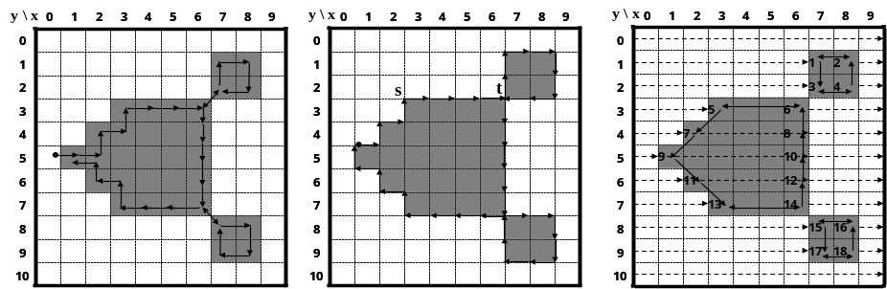
(a) Pixel following algorithm (b) Vertex following algorithm (c) Run-data-based following algorithm
Figure 1. Contour tracer

Pixel Following Method
The pixel following method traces contour pixels in a predefined manner and then saves their coordinates in the memory according to the trace order. In figure 1 (a), the algorithm traces contour pixels along the clockwise direction from the current pixel, i.e., it sequentially searches adjacent black pixels of the current pixel using a relative directional order such as left, front-left, front, front-right, right, right-rear, and rear. pixel following methods such as simple boundary follower (SBF) [2], [4], [5], modified SBF (MSBF) [3], improved SBF (ISBF) [6], Moore-Neighbor tracing (MNT) [7], radial sweep algorithm (RSA) [7],[8], and Theo Pavlidis algorithm (TPA) [7],[9] have simple rules for tracing contour pixels based on a chain code. On the contrary, it requires [Note: See Editor’s Note #2.] frame size memory to trace the contour, and it also generates nonerroneous images when the contour image is enlarged [11] since it maintains only the pixel coordinates.

Vertex Following Method
The vertex following method traces the vertices of the contour pixels that are located on the edges between the contour pixels and the background pixels [11]. Its procedure is similar to that of the pixel following method since it uses a chain code and requires a frame size memory for contour tracing; however, it traces the corners of the contour pixels and their connected edges. Moreover, it stores the corner points of the contour pixels in order to save the traced contour information and the data can be compressed by reducing the number of points in a straight line. For example, in figure 1 (b), five points of the contour from s to t can be stored as just two points such as (2.5, 2.5) and (6.5, 2.5) based on the (x, y) coordinate system. Moreover, when the contour images are enlarged, the vertex following method can provide the correct image [11] since the traced points form the boundaries of the contour.

Run-data-based following method
The run-data-based following method, involving the edge-point tracing of rundata [miyatake], [shoji], [Note: See Editor’s Note #3.] uses rundata in pairs consisting of the left and right edges of an object obtained by horizontal scan lines from left to right on an image. The object can have an outer contour and additional inner contours; therefore, the rundata has four types: (left edge of outer contour, right edge of outer contour), (left edge of outer contour, left edge of inner contour), (right edge of inner contour, left edge of inner contour), and (right edge of inner contour, right edge of outer corner). For contour following, the run-data-based following method constructs a run-following relationship between the edge points of two adjacent scan lines. In figure 1 (c), scan line #3 detects (left edge of 5, right edge of 6) and scan line #4 detects (left edge of 7, right edge of 8), and subsequently the run-following relationships between 5 and 7 and between 8 and 6 are generated. The method uses only one or two line buffers; therefore, it requires a smaller amount of memory as compared to the pixel following and vertex following methods since it uses only one or two scan lines. Examples of the method are run-type direction code (RD code) method [11] and PXY table based method [13].
Table 1 lists the characteristics of the contour following methods. The pixel following method and vertex following method trace contours without scanning all the pixels of the image and their transition data such as contour points and the tracing sequence are generated automatically by the contour following process. Therefore, they need not scan all the pixels but only a few pixels for obtaining the first contour pixel for the starting point of the object. Despite these merits, they are not suitable for large images with many objects since they require more operations and a larger memory as compared to the run-data-based following method, i.e., they scan all the pixels with an image buffer size memory to obtain all the objects and have several additional operations to detect whether or not to follow a contour pixel for all the contour pixels and their adjacent background pixels (see figure 8).
Table I
Comparison of contour following algorithms
 | Pixel following method | Vertex following method | Run-data based following method
Traced object | Contour pixel | Vertex of contour (pixel corner) | Run-data
Data construction | Coordinates of contour pixels by traced sequence  (automatically) | Coordinates of vertices of contour pixels by traced sequence  (automatically) | All run-data of image and run-following relationship data  (additive operation for calculating relationship among adjacent run-data horizontally)
Adaptive application [11] | Small scale image  Slow trace is allowed | Small scale image  Slow trace is allowed | Large scale image such as document recognition

On the contrary, the run-data-based following method searches the edge points with a smaller memory and constructs run-following relationships between edge points. Therefore, the traced run-following results are changed iteratively while the edge points are updated. The method is not simple but it is faster than the other methods in the case of a large-scale image since it scans all the pixels once, and it does not require any additional operations to be carried out on the pixels. Hence, it is suitable for large-scale-image-based applications involving a large number of objects such as document recognition [11].

Conventional Contour Tracing Algorithms
Let I be a binary digital image with M  N pixels where the coordinate of the top-left-most pixel is (0, 0) and that of the bottom-right-most pixel is (M – 1, N – 1). In I, a pixel can be represented as P = (x, y), x = 0,1,2….,M – 1, y = 0,1,2,…N – 1. Most contour tracing algorithms uses a tracer T (P, d) with absolute directional information, and they have the following basic sequence:
- The tracer starts contour tracing at a contour of an object after it saves the starting point along with its initial direction.
- The tracer determines the next contour point using its peculiar rule of following paths on the basis of the adjacent pixels and then moves to the contour point and changes its absolute direction.
- If the tracer reaches the start point then the trace procedure is terminated.

For determining the next contour point, which could be a contour pixel or pixel corner, the tracer detects the intensity of its adjacent pixel P_{r} and the new absolute direction d_{r} for P_{r} by using relative direction information. For example, if the absolute direction of the current tracer T(P, d) is N, the left direction of the tracer d_{Left} is W. Similarly, the left pixel of tracer P_{Left} is (x – 1, y). Figures 2 (a) and (b) show the directional information of the tracer and figure 2 (c) shows the types of contour pixels. The contour pixels can be classified into four types, namely, straight line, inner corner pixel, outer corner pixel, and inner-outer corner pixel. In figure 2 (c), “O” represents the outer corner; “I,” the inner corner; and “IO,” the inner-outer corner according to the local pattern of the contour.
In this study, we focus on a contour tracing algorithm that is suitable for situations involving a relatively small number of objects and requiring real-time tracing such as AR, MR, and recognition image-based code in small scale images, e.g., the mobile computing environment. Hence, we first introduce and briefly describe the conventional contour tracing algorithms that are used in this environment and analyze their tracing accuracy and characteristics.
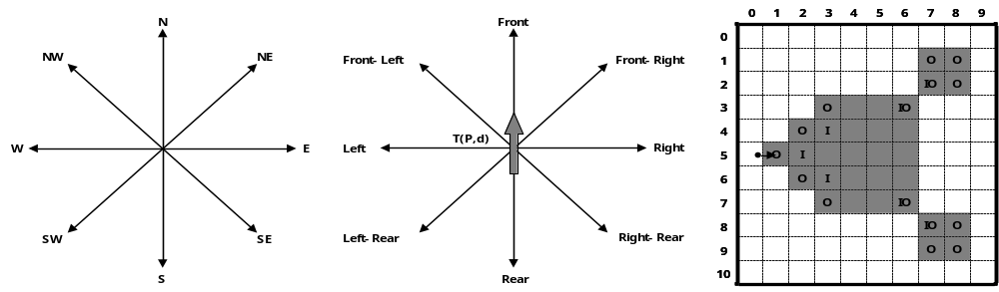
(a) absolute direction d (b) relative direction r (c) Types of contour pixels
Figure 2. Directions and types of contour pixels

Simple Boundary Follower
SBF is also known as Papert’s turtle algorithm [4] and as square tracing algorithm [7], and it is the simplest contour tracing algorithm. Initially, the location of tracer S is saved, and the tracer moves leftward or rightward; if the pixel tracer is located on a contour pixel, the tracer moves leftward, otherwise it moves rightward. The procedure is as given below.
Procedure_SBF
T(P,d) ←S(P,d)
Do
If P = black then T(P,d) ←T(PLeft,dLeft)
Else T(P,d) ←T(PRight,dRight)
While T(P,d)≠S(P,d)
End_ SBF

Modified Simple Boundary Follower
SBF cannot trace an inner-outer corner pixel that is located at the left-rear. MSBF [3] was invented to trace these pixels. If the tracer is adjacent to the left-rear inner-outer corner, this condition implies that its left-rear pixel is black (object) and the left and rear pixels are white (background); the tracer will move to the left-rear pixel and its direction is then changed toward the rear direction. After the movement, the tracer goes directly to the left pixel to avoid an infinite loop. Figure 3 [3?] shows examples of the SBF and MSBF paths for a left-rear direction inner-outer corner. In the case of the SBF, if the tracer is on pixel A with direction N, it misses pixel B. On the contrary, the MSBF can detour pixel B.
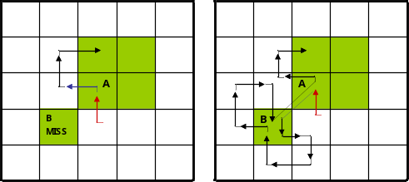
(a) SBF (b) MSBF
Figure 3. Detour of inner-outer corner at left-rear pixel

Improved Simple Boundary Follower
The SBF and MSBF require movement operations for both contour and background pixels; therefore, they waste time during movement on the background pixel and they cannot trace the inner corner pixel in front of the tracer [6], [7]. Hence, the ISBF [6] is proposed based on our previous research for overcoming these limitations. The ISBF has six cases for following contour pixels based on the local patterns of the contour pixels. the modified version of ref. [10] is as follows:
Procedure_ISBF
T(P,d)←S(P,d) where P is on black
Do
If PLeft = black then T(P,d)←T(PLeft,dLeft)
Else
If PLeft-Rear = black and PRear=white then T(P,d)←T(PLeft-Rear,dRear)
If PFront-Left = black
If PFront = black then T(P,d)←T(PFront,d) and T(P,d)←T(PLeft,d)
Else T(P,d)←T(PFront-Left,d)
Else If PFront = black then T(P,d)←T(PFront,dRight)
Else T(P,d)←T(P,dRear)
While T(P,d)≠S(P,d)
End_ISBF

Figure 4 represents the tracing path of the ISBF based on the local contour patterns. While the SBF cannot trace in cases (b) and (d), and the MSBF cannot follow in case (d), the ISBF successfully traces in all the cases. In the figure, the way point (dotted line) is a pixel [Note: See Editor’s Note #4.] that is subjected to a detection operation for determining whether it is black or white without employing a movement operation.
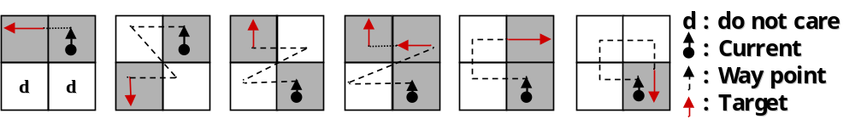
(a) Left neighbor (b) Innerouter corner at left-rear (c) Innerouter corner at front-left (d) Inner corner at front (e) Front neighbor (f) Outer corner
Figure 4. Contour cases of ISBF [cheong2]

Moore-Neighbor Tracing
MNT finds the next contour pixel using 8 connected chain codes [Note: Please check the change.] using a clockwise sequence starting from the rear pixel of the tracer, i.e., the tracer first moves toward the rear (T (P_{Rear}, d_{Rear})) and finds the next clockwise contour pixel such as the left-rear, left, font-left, front, front-right, right, and right-rear pixels [7].

Radial Sweep Algorithm
RSA [8] is similar to MNT, but its tracer has no directional information. Therefore, it maintains two points, namely, previous pixel and current pixel for the initial tracing direction. Figure 5 (b) illustrates an example of a tracing path by using RSA from P_{i} to P_{i+2}. In the figure, the direction vector from P_{i} to P_{i-1} is first generated, and then the tracer searches for the next contour pixel using the previous pixel P_{i-1} for the clockwise direction of the vector.
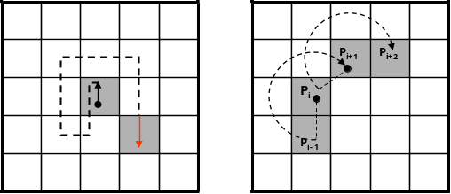
(a) MNT (b) RSA
Figure 5. Contour following sequence of MNT and RSA

Theo Pavlidis Algorithm
TPA [9] considers only three adjacent pixels, e.g., front-left, front, and front-right for determining the next contour pixel. If all the three pixels are white, the tracer turns right. Figure 6 describes its sequence.
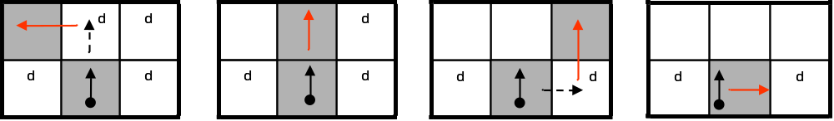
(a) Front-Left contour (b) Front contour (c) Front-Right contour (d) Rotation
Figure 6. Contour following sequence of TPA [cheong2]

Conventional Data Compression and Restoration
The RD code method [11] comprises two major techniques. One traces the contour on the basis of the hybrid method using vertex following with rundata and generates the corresponding RD codes. The other generates compressed contour data that can be used to restore the contour on the basis of representative points and their corresponding RD codes. The representative points are selected from the vertices of contour pixels and they are feature points of the contour. Moreover, the RD code can represent 10 local contour patterns and their corresponding following paths. Therefore, saving the representative points and their corresponding RD codes rather than all the contour points can reduce the memory size used to store the contour data. Figure 7 (a) [11] gives an example of representative points. The representative points in the RD method are of four types, namely, two outer corner points and two inner corner points, as shown in figure 7 (b). Although this technique can save data in small files; it does not consider the inner-outer corner pixel. [Note: Please check the change.]
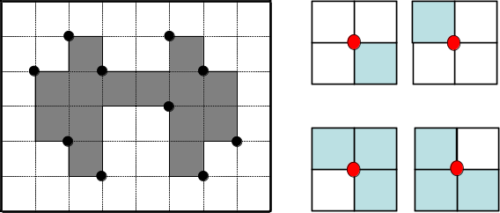
(a) Representative points [miyatake] (b) Cases of representative points
Figure 7. representative data points for data compression [Note: Please check the change.].

Analysis of conventional contour following algorithms
Figure 8 illustrates the tracing results of pixel following methods based on the contour shown in figure 1. In the figure, the arrow with an anchor is the tracer at the starting pixel, a solid arrow shows the movement operation of the tracer, and a dotted line is the way point (detected pixel) for determining whether or not the pixel is a contour pixel for pixel following.
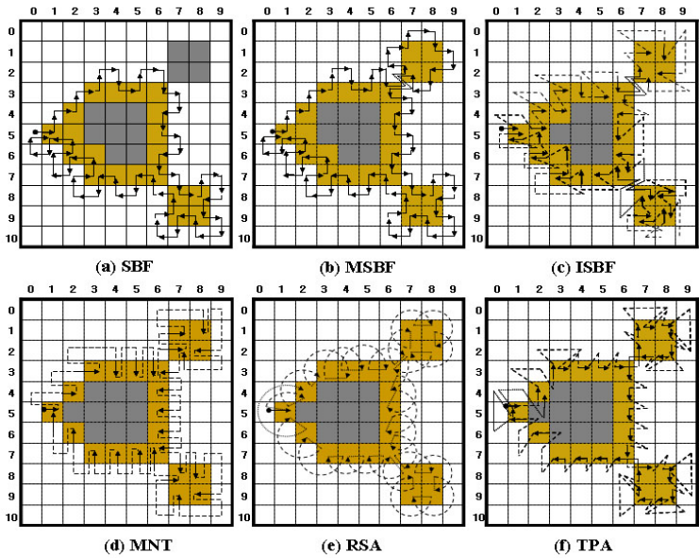
Figure 8. Comparison of conventional contour pixel following algorithms.

Cases of pixel following
As shown in figure 8, the ISBF traces most types of contour pixels such as the inner corner, outer corner, inner-outer corner, and straight line pixels. In the case of the SBF, there are inconsistencies regarding tracing at the inner corner and inner-outer corner. For example, in the figure, the inner corner pixel (3, 6) and inner-outer corner pixel (7, 8) are traced, but the inner corner (3, 4) and inner-outer corner (7, 9) pixels are missed. In the case of the MSBF, all the inner-outer corner pixels are traced, but it has inconsistencies with regard to tracing the inner corner pixel. Moreover, the MNT, RSA, and TPA have no inconsistency problems but they cannot trace the inner corners. Among these algorithms, the TPA can be easily changed to trace an inner corner pixel since it has way points on the inner corners, as shown in figure 8 (f).

Start-up condition and stopping criteria
The pixel following algorithm functions under the criteria of start and stop [Note: Please check the change.] to avoid incompleteness of tracing and infinite tracing.

Assumption for start
Commonly, start of tracing occurs when the tracer enters a black pixel from a white pixel. Due to this reason, at the start of tracing, the tracer must be placed on a black pixel and its rear pixel P_{Rear} should be white. Moreover, in the case of the MSBF and ISBF, if the P_{Left-Rear} of the start pixel is an inner-outer corner pixel, they cannot trace all the contour pixels by using their stopping criteria [10]. In addition, TPA has to select a start pixel that has white pixels at the tracer positions P_{Left}, P_{Left-Rear}, and P_{Right-Rear} [7]; otherwise, it cannot trace the left pixel of the contour.

Stop criterion
There are three methods for stopping the contour tracing [7]. The first method is Jacob’s stopping criterion [7] that terminates the trace when the tracer reenters the start pixel with an absolute direction that is the same as the start direction, i.e., if the current tracer T (P,d) is the same as the start tracer S (P,d), the pixel following is terminated. The SBF, MSBF, and ISBF use this criterion and their tracing terminates at the start pixel, as shown in figures 8 (a)–(c). The second method uses the number of reentries [Note: Please check the change.] to the start pixel. In figures 8 (d) and (f), the tracers of MNT and TPA revisit the start pixel (1, 5) with different directional information; therefore, they do not stop but go to the next contour pixel if the first method is applied. For this reason, if a specified number [Note: Please check the change.] of reentries such as three or four times is satisfied, the trace is terminated [7]. Sometimes, this method is not efficient because it requires unnecessary tracing to be performed one or more times. The final method checks the trace route that is traced by the previous pixel and current pixel of the tracer and determines whether or not it has already been passed. This method is used for RSA [7], [8] since its tracer has no directional information but only pixel location information. In other words, whenever the tracer enters the i^{th} contour pixel, the current pixel location P_{i} is appended sequentially into the traced contour path. Moreover, if the traced path of (P_{i-1}, P_{i}) appears twice, the tracing is terminated. This method can be applied for all pixel following methods and it is simpler than the second method; however, it requires more operations than Jacob’s stopping criterion.

Limitations of conventional pixel following methods
The abovementioned conventional pixel following methods have certain limitations. First, some of the algorithms such as SBF and MSBF perform unnecessary movement operation on a white pixel, as shown in figures 8 (a) and (b). Second, all the algorithms cannot define the contour in the case of contour pixels; therefore, they cannot be a descriptive feature of the object and determine connectivity among objects. For example, in figure 8 (b), the MSBF detects (2, 7) as the inner-outer corner pixel, but does not indicate (8, 7) as an inner-outer corner because the traced paths on the pixels are different. Moreover, the MSBF also cannot determine the inner corner, outer corner, and straight line pixel like the SBF does. In case of the ISBF, it determines the inner-outer corner, front inner corner, and front straight line pixels but cannot determine the left inner corner, left straight line and some of the outer corner pixels, as shown in figure 8 (c). Similarly, MNT and RSA cannot determine and detect the inner corners, and TPA cannot classify the contour pixels into the different types of contour pixels. Finally, the data size of the traced contour must be considered. The pixel following methods save all the pixel points; therefore, their data are larger than those of the RD code method

Proposed Contour Tracing Algorithm
In this section, we propose a novel pixel following algorithm that traces contour pixels by considering their local patterns. Therefore, it can classify the contour pixel into contour types such as inner corner, outer corner, inner-outer corner, and straight line; further, it can easily determine the next contour pixel. Moreover, it can determine and save representative points of an image, like the RD code method, by using pixel following but not using run-data-based following. In addition, the data can be restored to the original contour pixels without the RD code data.

Contour Following

Assumptions for start-up and stopping criteria
The proposed algorithm runs under two assumptions for start. One is the general condition for pixel following: the rear pixel of the tracer on the start pixel is white. The other is that there is no left-rear inner-outer corner for the tracer at the start position, i.e., if the rear and the left pixels are white and the rear-left pixel is black, the start pixel has to be changed. These are the same starting conditions as those for the MSBF and ISBF. Moreover, the stop criteria of the proposed algorithm is Jacob’s stopping criterion and the tracer is always on a contour pixel.
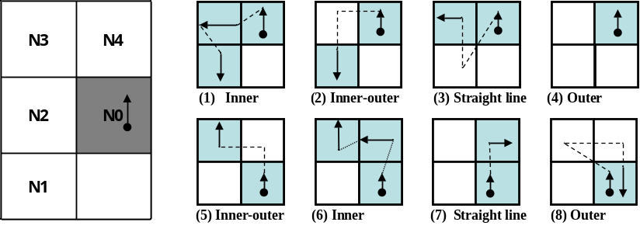
(a) Adjacent pixels (b) Contour cases
Figure 9. Contour tracing cases of the proposed contour following algorithm.

Procedures

The proposed algorithm has two stages. First, the tracer follows the contour pixel on the basis of the intensities of the left-rear and left pixels. After that, the tracer follows the contour pixels on the basis of the intensities of the front and front-left pixels. Figure 9 shows the contour tracing cases of the proposed contour following algorithm. In the figure, the tracer is first on N0 queries states of N1 and N2, as shown in figure 9 (a), and then the states determine the corresponding path to trace among cases (1)–(4), as shown in figure 9 (b). After stage 1, the moved tracer queries states N3 and N4 and then it traces contour pixels along the corresponding path using the states among cases (5)–(8).
Hence, by using the proposed algorithm, the inner corners are traced as case (1) or case (6), the inner-outer corners are traced as case (2) or case (5), the outer corners are determined as case (4) or case (8), and the straight line pixels are determined as the other cases. Therefore, all the cases are easily classified by using the algorithm.
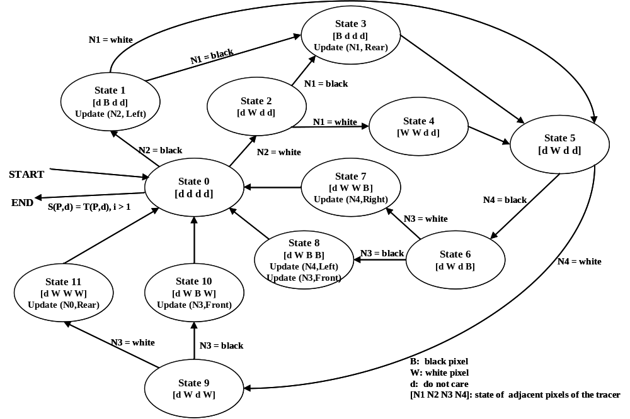
Figure 10. The state transition of the automation for the proposed algorithm.

States
figure 10 describes the state transition for the automation of the proposed algorithm. In the figure, the start and termination occur at State 0; the first stage runs using States 1–4 and then it transits to state 5. the second stage continues from state 5 using states 6–11 and then it transits to state 0. For example, case (1) in figure 9 can be executed by the transit sequence state 1, state 3, and state 5.
In figure 10, [N1 N2 N3 N4] represents the intensity vector of the tracer’s four adjacent pixels shown in figure 9 (a). In the vector, d implies “do not care”; B, a contour pixel (black); and W, the background pixel (white). Moreover, Update (P,d) refers to the movement operation where P is the new contour pixel location and d is the new directional information for the tracer. In state 1 and state 3, the updates occur based on the tracer of state 0, and other updates are based on the tracer information in state 5.

Characteristics of the proposed algorithm
We designed the proposed algorithm based on two stages with two major goals. First, the check operation for stopping occurs only at state 0; therefore, the number of checking operations on black pixels are reduced. In other words, the proposed algorithm examines that the check operation occurs when only the tracer has a white rear pixel. this is more efficient as compared to the check operation occuring for every contour pixel because its start condition and stop criterion also satisfy that the rear pixel of the tracer on the start pixel. [Note: See Editor’s Note #5.] Therefore, the transition of stage 2 to States 6 to 11 for processing cases (5) to (8) is designed such that it can be returned to state 0 only if the tracer has a white rear pixel, and it reduces any unnecessary operations for checking to stop. Besides, the tracers of cases (2) and (4) have a white rear pixel after movement but their end conditions are not considered. In case (2), at the start the tracer [Note: Please check the change.] avoids the inner-outer corner pixels as the start and end pixel. Moreover, in case (4), the tracer has no update; therefore, it is unnecessary to perform check operation twice.
Second, the proposed algorithm reduces some of the redundant operations used for detecting white pixels. The conventional algorithms do not consider white pixels in the previous path; therefore, they sometimes redetect white pixels on the previous tracing during the current tracing. For example, in figure 8, the white pixel at (4, 2) is detected twice while determining contour pixels such as (4, 3) and (5, 3). Moreover, RSA detects (4, 2) three time while determining (4, 3), (5, 3), and (6, 3). On the contrary, the proposed algorithm has two stages and its second stage avoids the previous path. Figure 11 shows the contour tracing results for the proposed algorithm and it detects (4, 2) once for contour tracing. Moreover, the figure shows that the proposed algorithm has fewer operations on the white pixels as compared to conventional pixel following methods, as shown in figure 8, and traces all the types of contours. [Note: Please check the change.]
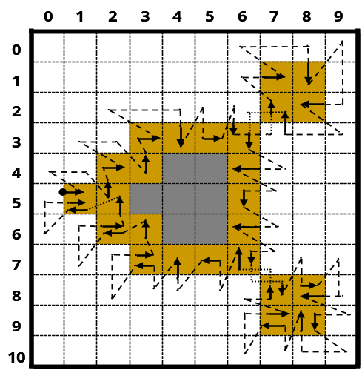
Figure 11. Tracing result of the proposed algorithm.

The pseudo-code of the proposed algorithm is as below:
Procedure_Proposed_Tracer

T(P,d)←S(P,d) where P is on black, P_{Rear} is on white and i←1
// Whenever T(P,d) is updated, i increases 1 and T(p’,d’) is saved automatically
Do
// Stage 1
IF P_{Left}-_{Rear}=black
IF P_{Left}=black then
T(P,d)←T(P_{Left},d_{Left}) and Code(i)←”Inner” and T(P,d)←T(P_{Left},d_{Left}) // case 1

ELSE Code(i)←”Inner-outer” and T(P,d)←T(P_{Left-Rear},d_{Rear}) and Code(i)←”Inner-outer” // case 2
ELSE
IF P_{Left}=black then T(P,d)←T(P_{Left},d_{Left}) and Code(i)←”Straight” // case 3
ELSE Code(i)←”Outer” // case 4

// Stage 2
IF P_{Front-Left}=black
IF P_{Front}=black then
T(P,d)←T(P_{Front},d_{Left}) and Code(i)←”Inner” and T(P,d)←T(P_{Front},d_{Right}) // case 6
ELSE Code(i)←”Inner-outer” T(P,d)←T(P_{Front-Left},d) and Code(i)←”Inner-outer” // case 5
ELSE IF P_{Front}=black then T(P,d)←T(P_{Front},d_{Right}) // case 7
ELSE T(P,d)←T(P,d_{Rear}) and i = i-1 and Code(i)←”Outer” // case 8
While T(P,d)≠S(P,d)

End_Proposed_Tracer

Table 2 describes the tracing results obtained by using the proposed algorithm up to the stage the tracer enters the 11th pixel. The code represents the contour pixel type and it is classified automatically during tracing. In the table, Code (i) [Note: See Editor’s Note #6.] has only one code, the contour pixel type, but it can have several codes, for example, there is an outer corner pixel and an inner-outer corner pixel. [Note: Please check the change.]
Table II.
Result table of the proposed contour tracing
Sequence (i) | P |  | Code
Sequence (i) | x | y | Code
1 | 1 | 5 | Outer
2 | 2 | 5 | Inner
3 | 2 | 4 | Outer
4 | 3 | 4 | Inner
5 | 3 | 3 | Outer
6 | 4 | 3 | Straight
7 | 5 | 3 | Straight
8 | 6 | 3 | Inner-outer
9 | 7 | 2 | Inner-outer
10 | 7 | 1 | Outer
11 | 8 | 1 | -

Data compression and restoration
The proposed algorithm saves representation points and the inner-outer corner points in the form of compressed data in order to reduce the data size. The representation points are feature points that are used for storing and restoring contour pixels, while the inner-outer corner points are used for accurately restoring the inner-outer corner pixels.

Data structure
The representative points and inner-outer corner points are represented as vertices of contour pixels. Figure 12 (a) shows the point types of the proposed algorithm. The representative point is of seven types, namely, two outer corners, two inner corners, and one inner-outer corner. Moreover, the inner-outer corner point has two types. Figure 12 (b) illustrates all cases of contour tracing for the proposed algorithm and their corresponding representative points and inner-outer corner points.
These points are saved as a sequence during contour tracing. If an i-th representative point R_{i} is equivalent to (r_{i,x}, r_{i,y}), then the set of representative points R is given by {R₀, R₁, R₂, … , R_{n-1}} and R₀ = R_{n} because the starting and ending points are the same. Similarly, if C_{j} is the j-th inner-outer corner point, it can be represented using its coordinate and its type. The type of the point C_{j},_{T} is assigned to be NW-SE or NE-SW, as shown in figures 12 (a). Table 3 shows the data structure for data compression and restoration of the contour pixels by using the proposed algorithm.
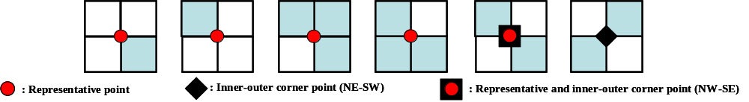
(a) Representative points and inner-outer corner points
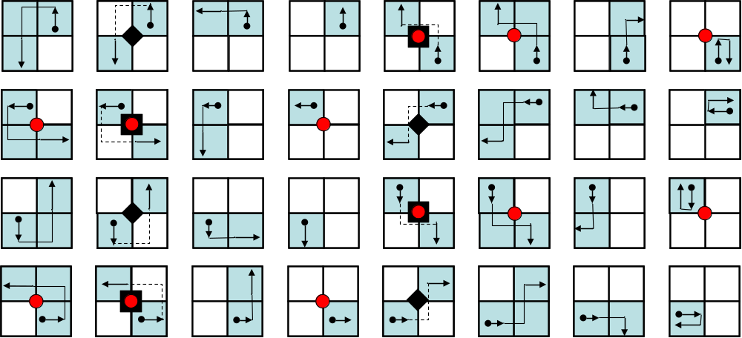
(b) Cases of the proposed algorithm
Figure 12. Representative points and inner-outer points in contour cases
Table III.
Data structure of the proposed contour tracer
Representative Points (R_{i}) |  | Inner-outer Corner (C_{j})
x | y | x | y | Type
r_{1,x} | r_{1,y} | c_{1,x} | c_{1,y} | c_{1,T}
r_{2,x} | r_{2,y} | c_{2,x} | c_{2,y} | c_{2,T}
… | … | … | … | …

Contour pixel restoration
For restoration, we proposed a restoration algorithm comprising two stages, namely, contour restoration and inner-outer corner restoration.

Contour restoration with representation points
The sequence of representative points is important information for reconstructing the contour pixels because it represents the contour tracing sequence. Hence, by using the sequence of representative points and the relative location between adjacent representative points in the representative point table, the contour can be restored easily. If there are two sequential representative points R_{i} and R_{i+1}, 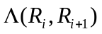 as the relative position classifier from R_{i} to R_{i+1} can be described as
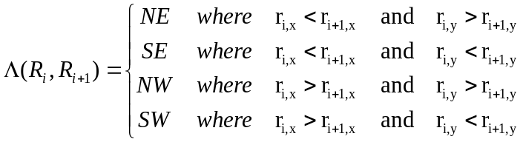. (1)
Figure 13 shows the contour pixel reconstruction methods using the relative positions from R_{i} to R_{i+1}. In the case of SE or NW, the contour pixels are filled in a clockwise manner and in the other cases, these pixels are filled in a counterclockwise manner.
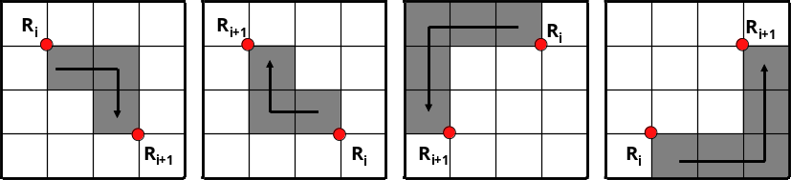
(a) SE (b) NW (c) SW (d) NE
Figure 13. Contour pixel reconstruction
The methods in figure 13 are the basic methods for restoring the contour, but they have a problem in reconstructing the inner corner pixel using three or more representative points. Table 4 and figure 14 show cases of missing inner corner pixels using [Note: Please check the change.] sequential representative points R_{i}, R_{i+1}, and R_{i+2}.
Table IV.
Examples of inner corner missing
Case | 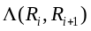 | 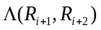
1 | SE | NE
2 | SE | SE
3 | NE | SW
4 | NE | NW
5 | NW | NW
6 | NW | SW
7 | SW | SE
8 | SW | NE

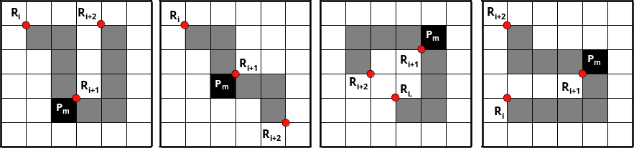
(a) Case 1 (b) Case 2 (c) Case 3 (d) Case 4
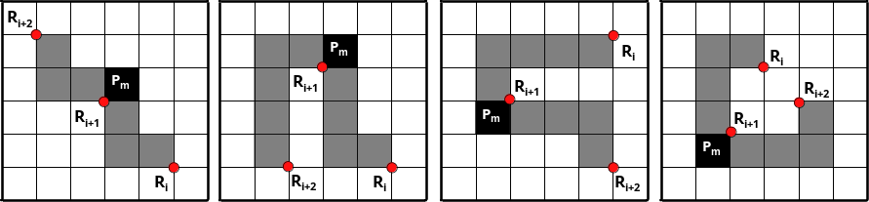
(e) Case 5 (f) Case 6 (g) Case 7 (h) Case 8
Figure 14. Restoration cases for different sequences of representation points
As shown in the figure, the three representative points cannot restore the inner corner pixel P_{m}. Therefore, if the three sequential points form one of the cases in table 4, P_{m} of the middle representative point R_{i+1} must be filled with black.
This reconstruction method is different from the restoration in the RD code method since the proposed method does not need the RD code but requires only representative points, and their saved sequence naturally replaces the RD code. Therefore, it requires a smaller memory size as compared to the RD code method.

Inner-outer corner restoration
The restored contour using only the representative points has no inner-outer corners since the inner-outer corner is not considered. For this reason, if there are inner-outer corner points in the data table, as shown in Table 3, the inner-outer corners are generated by using the data C_{j} with their point coordinates and types. If a pixel restored using the representative points is o(x, y) ∈ O [Note: See Editor’s Note #7.], the function of the inner-outer corner restoration, R_{IO}, can be obtained as
. (2)

Experimental Result
For comparing the proposed algorithm with conventional algorithms, we perform experiment for determining their accuracy, speed, and stored data size. Table 5 shows the experimental environment.
Table V.
Experimental Environment
 | Desktop | Notebook (Samsung Sens V20)
CPU | Intel® Core™2 CPU 6300 1.86 GHz | Intel® Pentium® 4 1.80GHz
Memory | 512MB | 256MB (PC133 SDRAM)
HDD | Samsung UDMA 133 7200RPM 8MB Buffer | Hitachi UDMA 100 4200RPM 2MB Buffer
O/S | Microsoft Windows XP SP2
Development | Microsoft Visual Studio 6.0 C++

We experimented on nine CCITT standard fax images with 200 DPI (dots per inch) [14]. All these images have 1,728 × 2,339 pixels and a file size of 11,842 KB. Table 6 shows the document type of these images and the total number of contour pixels. We used these large sized images because they a number of various types of contours, and they are useful to compare the efficiencies with regard to parameters such as processing time and accuracy of the trace results of the contour tracing algorithms.
Table VI.
CCITT Fax Standard Images
Index | Type | Total number of contour pixels
#1 | Business letter | 81,189
#2 | Circuit diagram | 50,825
#3 | Sales order table | 152,489
#4 | French document | 312,812
#5 | Technical paper | 157,377
#6 | Technical graph | 98,579
#7 | Japanese document | 283,717
#8 | Handwritten memo | 97,031
#9 | Facsimile test chart | 453,721

In order to compare the proposed algorithm with conventional algorithms, we used the experimental method described in ef. [12] for determining the start pixels of the outer and inner contours of the images. In other words, whenever any untraced contour pixel is searched using a raster scan from the left-top to the right-bottom of the images, this pixel is regarded as the start pixel and the tracer starts contour tracing. If the contour is an outer contour, the tracer’s initial direction is assigned as East (“E”). On the contrary, in the case of the inner contour of an object e.g., “e,” “p,” “q,” “R,” and “o,” the tracer’s initial direction is assigned as West (“W”), as shown in figure 2 (a).
In the experiment, we did not consider the TPA, since the initial condition of the TPA [7], [9] is that it must start with white L, W, and R pixels [Note: Please check the change.], which is not satisfied in some of the inner contours. Figure 15 shows an example of this violation. In our experimental situation, there were many cases in which such conditions were not satisfied; therefore, we could not perform identical experiments and meaningful data was not obtained for comparing the trace results with those of the other methods.
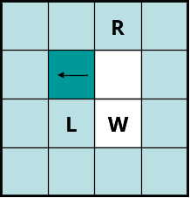
Figure 15. Problem of TPA

Accuracy
The accuracy of contour tracing involves determining how accurately the tracing algorithm traces, and we measure it by counting the number of pixels traced. Firstly, we apply each algorithm to the test images and mark the tracing on the images. Then we count all the marked pixels in the images. Therefore, even if a pixel is traced several times, it is counted only once. Table 7 shows the results of the comparison between the proposed algorithm and the conventional ones. In the table, “total number” implies the total number of contour pixels, including the inner corner, outer corner, inner-outer corner, and straight line pixels. In this result, the MNT and RSA traced the least number of pixels as contours because they could not trace the inner corner pixels. the SBF has inconsistencies with regard to the inner-outer corner and inner corner types; therefore, it traced lesser number of pixels as compared to the ISBF and proposed algorithm. [Note: Please check the change.] Further, the MSBF has inner corner inconsistencies that are similar to those of the SBF; the MSBF traced lesser number of pixels as compared to the proposed algorithm and ISBF. The proposed algorithm shows that 99.5% of the total contour pixels were found to be the same as those in the case of the ISBF and it has the maximum total number of traced contour pixels. In conclusion, the proposed algorithm produced the best results with regard to tracing accuracy.
Table VII.
Comparison of traced contour pixels.
Image | Total  Number | Proposed |  | ISBF |  | MSBF |  | SBF |  | MNT |  | RSA
Image | Total  Number | Number | % | Number | % | Number | % | Number | % | Number | % | Number | %
#1 | 81,189 | 81,188 | 100.0 | 81,188 | 100.0 | 73,743 | 90.8 | 73,613 | 90.7 | 65,503 | 80.7 | 65,503 | 80.7
#2 | 50,825 | 50,824 | 100.0 | 50,824 | 100.0 | 45,003 | 88.5 | 45,003 | 88.5 | 38,819 | 76.4 | 38,819 | 76.4
#3 | 152,489 | 152,487 | 100.0 | 152,487 | 100.0 | 139,589 | 91.5 | 139,589 | 91.5 | 126,414 | 82.9 | 126,414 | 82.9
#4 | 312,812 | 312,812 | 100.0 | 312,812 | 100.0 | 283,709 | 90.7 | 283,712 | 90.7 | 253,169 | 80.9 | 253,169 | 80.9
#5 | 157,377 | 157,374 | 100.0 | 157,374 | 100.0 | 142,447 | 90.5 | 142,453 | 90.5 | 127,306 | 80.9 | 127,306 | 80.9
#6 | 98,579 | 98,566 | 100.0 | 98,566 | 100.0 | 91,176 | 92.5 | 91,174 | 92.5 | 82,239 | 83.4 | 82,239 | 83.4
#7 | 283,717 | 283,551 | 99.9 | 283,551 | 99.9 | 264,108 | 93.1 | 264,067 | 93.1 | 238,533 | 84.1 | 238,533 | 84.1
#8 | 97,031 | 97,015 | 100.0 | 97,015 | 100.0 | 86,822 | 89.5 | 86,822 | 89.5 | 76,251 | 78.6 | 76,251 | 78.6
#9 | 453,721 | 445,975 | 98.3 | 445,972 | 98.3 | 417,687 | 92.1 | 417,735 | 92.1 | 361,439 | 79.7 | 361,439 | 79.7
Total | 1,687,740 | 1,679,792 | 99.5 | 1,679,789 | 99.5 | 1,544,284 | 91.5 | 1,544,168 | 91.5 | 1,369,673 | 81.2 | 1,369,673 | 81.2
Figure 16 shows the traced images resulting from the MSBF and proposed algorithm. In this figure, (a) could not trace some of the inner corner pixels but (b) traced all the corner pixel types without any inconsistency. Moreover, as the proposed algorithm can classify each corner type, it can trace the selected type of contour pixels by omitting some cases, as shown in figure 9 (b). For example, if we remove the tracing cases (1) and (6) from the other cases, we can obtain a result without inner corner tracing, and it is the same as the result of the MNT and RSA. Figure 17 (b) shows an image that is traced using the proposed algorithm without inner corners, and it shows that the image is consistently traced without inner corners.
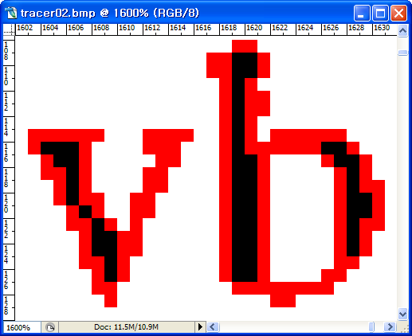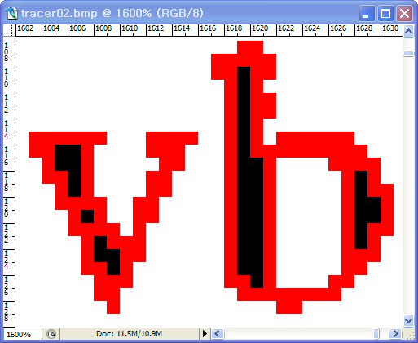
(a) MSBF (b) Proposed method
Figure 16. Comparison of contour tracing
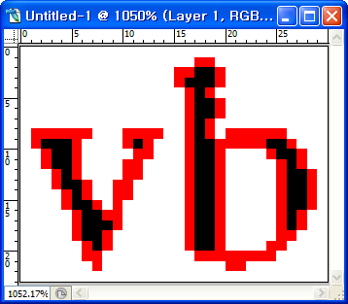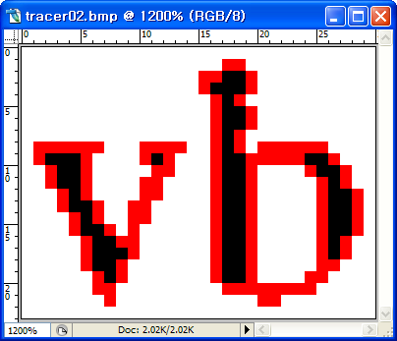
(a) MNT (b) Proposed method (without inner corners)
Figure 17. Comparison of contour tracing

Speed
In order to measure the tracing time for each algorithm, we performed each algorithm 10 times per image and calculated the average time. We used the GetTickCount() function supported by Microsoft Visual C++ 6.0 to measure the processing time. Tables 8 and 9 show the average processing time of each algorithm used for tracing the images, and a linear model for estimating the process time as the number of traced pixels increases by using the least-square estimation (LSE) method. In the tables, the average processing time per traced contour pixel is obtained by dividing the total processing time by the total number of traced contour pixels. They are measured on the desktop and notebook separately.
Table IIX.
Experimental Result from the desktop (Unit: Second)
Image | Proposed Algorithm | ISBF | MSBF | SBF | MNT | RSA
#1 | 0.0298 | 0.0311 | 0.0329 | 0.0313 | 0.0313 | 0.0375
#2 | 0.0216 | 0.0281 | 0.0296 | 0.0234 | 0.0236 | 0.0280
#3 | 0.0389 | 0.0404 | 0.0468 | 0.0376 | 0.0404 | 0.0470
#4 | 0.0703 | 0.0750 | 0.0922 | 0.0673 | 0.0687 | 0.0921
#5 | 0.0424 | 0.0454 | 0.0500 | 0.0433 | 0.0421 | 0.0500
#6 | 0.0296 | 0.0342 | 0.0375 | 0.0329 | 0.0312 | 0.0343
#7 | 0.0654 | 0.0735 | 0.0952 | 0.0688 | 0.0672 | 0.0874
#8 | 0.0312 | 0.0344 | 0.0392 | 0.0311 | 0.0311 | 0.0328
#9 | 0.0828 | 0.0937 | 0.1314 | 0.0889 | 0.0875 | 0.1094
Average | 0.0458 | 0.0506 | 0.0616 | 0.0472 | 0.0470 | 0.0576
Average time per traced contour pixel | 2.4510⁻⁰⁷ | 2.7110⁻⁰⁷ | 3.5910⁻⁰⁷ | 2.7510⁻⁰⁷ | 3.0910⁻⁰⁷ | 3.7910⁻⁰⁷
LSE | 1.62  10⁻⁰⁷ + 0.0156 | 1.79  10⁻⁰⁷ + 0.0173 | 2.87  10⁻⁰⁷ + 0.0124 | 1.79  10⁻⁰⁷ + 0.0164 | 2.03  10⁻⁰⁷ + 0.0161 | 2.77  10⁻⁰⁷ + 0.0155
R-square | 0.956 | 0.958 | 0.983 | 0.958 | 0.964 | 0.966
* Results of best or faster than the proposed algorithm are marked as shadow.

Table IX.
Experimental Result from Notebook (Unit: Second)
Image | Proposed Algorithm | ISBF | MSBF | SBF | MNT | RSA
#1 | 0.0470 | 0.0520 | 0.0531 | 0.0450 | 0.0510 | 0.0541
#2 | 0.0380 | 0.0380 | 0.0390 | 0.0350 | 0.0412 | 0.0401
#3 | 0.0670 | 0.0700 | 0.0751 | 0.0611 | 0.0752 | 0.0820
#4 | 0.1171 | 0.1250 | 0.1412 | 0.1061 | 0.1293 | 0.1454
#5 | 0.0680 | 0.0740 | 0.0780 | 0.0631 | 0.0731 | 0.0832
#6 | 0.0532 | 0.0531 | 0.0581 | 0.0501 | 0.0561 | 0.0600
#7 | 0.1142 | 0.1250 | 0.1441 | 0.1091 | 0.1330 | 0.1432
#8 | 0.0521 | 0.0521 | 0.0581 | 0.0490 | 0.0530 | 0.0591
#9 | 0.1593 | 0.1703 | 0.2031 | 0.1455 | 0.1731 | 0.2005
Average | 0.0795 | 0.0844 | 0.0944 | 0.0738 | 0.0872 | 0.0964
Average per contour pixel | 4.2610⁻⁰⁷ | 4.5210⁻⁰⁷ | 5.5010⁻⁰⁷ | 4.3010⁻⁰⁷ | 5.7310⁻⁰⁷ | 6.3310⁻⁰⁷
LSE | 3.10  10⁻⁰⁷ + 0.0217 | 3.39  10⁻⁰⁷ + 0.0210 | 4.46  10⁻⁰⁷ + 0.0179 | 3.01  10⁻⁰⁷ + 0.0221 | 4.26  10⁻⁰⁷ + 0.0223 | 5.00  10⁻⁰⁷ + 0.0203
R-square | 0.997 | 0.994 | 0.995 | 0.993 | 0.993 | 0.999
* Results of best or faster than the proposed algorithm are marked as shadow.
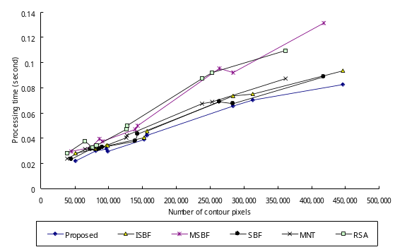 | 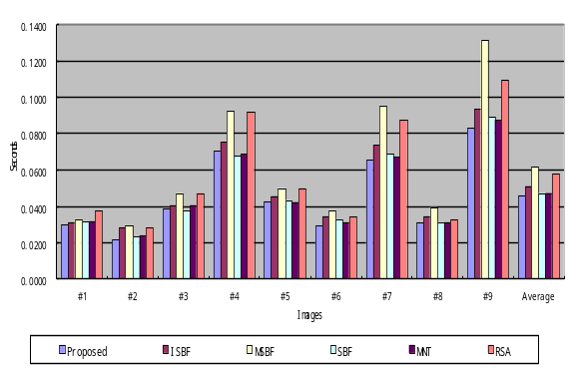
(a) Processing time vs. the number of contour pixels (desktop) | (b) Average contour tracing time vs. images (desktop)
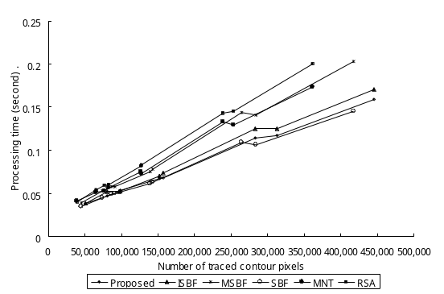 | 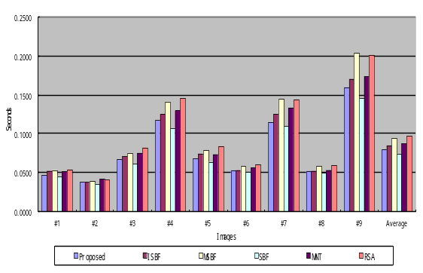
(c) Processing time vs. the number of contour pixels (notebook) | (d) Average contour tracing time vs. images (notebook)
Figure 18. Comparison of tracing times of contour tracing algorithms
Moreover, figure 18 illustrates a graph that uses data from tables 7 to 9. As shown in figures 18 (a) and (b), the proposed algorithm had the best performance in the case of the desktop, i.e., it had the least average processing time and showed the least increase in the ratio of process time to number of traced contour pixels, as shown in the LSE. In particular, although the proposed algorithm traced most of the numerous contour pixels in each image, it has the best or good performance when compared with the conventional algorithms. On the contrary, the SBF had the least average processing time for images and the least ratio from the LSE in the case of the notebook, and the proposed algorithm is second in rank based on the average processing time and LSE. from these experimental results the SBF is not the best algorithm for the note book because the ratio of the number of traced contour pixels is only approximately 92% of the proposed algorithm. Due to this reason, the proposed algorithm has better performance than the other algorithms for the number of traced contour pixels and the processing time.

Less Memory
The proposed algorithm does not save all the contour pixels, but it saves only the representative points and the inner-outer corner pixels. Table 11 shows the data size acquired from the above experiments on CCITT standard fax images. It shows the total number of contour pixels and compressed data. The number of entire contour pixels (A), which are same results from table 7 and the C and D in the table are data which are actually stored. [Note: See Editor’s Note #8.] A and C are the number of (x, y) coordinates, and D represents the number of inner-outer corners that comprise (x, y) coordinates and the type of inner-outer corner. The benefit of storing only the representative points based on the vertex of the contour pixel is that it can dramatically reduce the data size. This experimental results showed that the proposed algorithm reduced the data size to 19~60% of the memory used when all the contour pixels were stored, as shown in Table 11.

Table 11.
Comparison between total contour pixels and representative points
 | Entire contour pixels |  | Compressed data |  |  | Ratio (%)  (E / B * 100)
 | Number of contour pixels  (A) | Data size  (B = A*2) | Number of representative points  (C) | Number of Inner-outer corner points  (D) | Data size  (E = C*2+D*3) | Ratio (%)  (E / B * 100)
#1 | 81,188 | 162,376 | 21,206 | 61 | 42,595 | 26.23
#2 | 50,824 | 101,648 | 12,695 | 21 | 25,453 | 25.04
#3 | 152,487 | 304,974 | 30,181 | 53 | 60,521 | 19.84
#4 | 312,812 | 625,624 | 86,953 | 442 | 175,232 | 28.01
#5 | 157,374 | 314,748 | 37,386 | 113 | 75,111 | 23.86
#6 | 98,566 | 197,132 | 18,464 | 104 | 37,240 | 18.89
#7 | 283,551 | 567,102 | 84,484 | 1,539 | 173,585 | 30.61
#8 | 97,015 | 194,030 | 21,928 | 104 | 44,168 | 22.76
#10 | 445,975 | 891,950 | 158,529 | 75,425 | 543,333 | 60.92

Restoration

Figure 19 shows an example of retrieval points and a restoration result obtained by using the proposed restoration algorithm. Figure 19 (a) is an example image that has all the contour pixel types, and it depicts the representative points and inner-outer corner points for contour description and restoration. This image has two contours, namely, an outer contour and an inner contour that includes two inner-outer corners. Table 12 describes these data and figure 18 (b) shows the restoration results, which are retrieved using the data from table 12. In the figure, the restored contour accurately represents the original contour pixels.
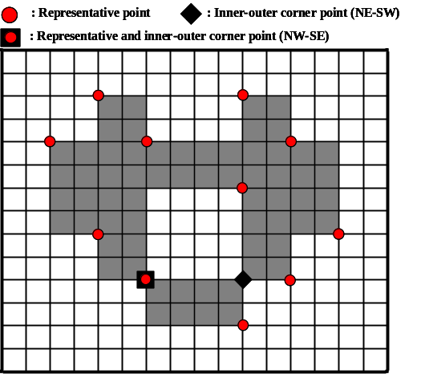
(a) Original image and its saved points for restoration (b) restoration by saved data
Figure 19 Example of restoration of contour pixels
Table 12.
Saved data
i | Contour #1. (outer contour) |  |  |  |  | Contour #2. (inner contour)
i | R_{i} |  | C_{i} |  |  | R_{i} |  | C_{i}
i | x | y | x | y | type | x | y | x | y | type
1 | 3.5 | 1.5 | 9.5 | 9.5 | NE-SW | 5.5 | 9.5 | 5.5 | 9.5 | NW-SE
2 | 5.5 | 3.5 | 5.5 | 9.5 | NW-SE | 9.5 | 5.5 | 9.5 | 9.5 | NE-SW
3 | 9.5 | 1.5
4 | 11.5 | 3.5
5 | 13.5 | 7.5
6 | 11.5 | 9.5
7 | 9.5 | 11.5
8 | 5.5 | 9.5
9 | 3.5 | 7.5
10 | 1.5 | 3.5
 
(a) Result of contour tracing (b) Result of contour restoration
Figure 20. Result of experiment for CCITT #1. Red pixels are contour pixels.
Figure 20 shows the result for the CCITT #1 image using the proposed restoration algorithm. Figure 20 (a) represents the result of contour tracing and (b) depicts the result of restoration from the compressed contour data. To verify the identity, we compared the contour pixels of the two images and they are identical with regard to the number of contour pixels and the pixel coordinates, i.e., the contour pixels in the restoration result is the same as the original contour pixels. As shown in figures 19 and 20, these experiments proved that the proposed algorithm could trace the inner and outer contours, and it could store the results using lesser memory by storing only the representative points and inner-outer corner points instead of all the contour pixels; moreover, it could accurately restore all the contour pixels correctly from the compressed data. Besides, as shown in Ref. [11], compressed data based on vertex contours guarantee precise scaling [Note: Please check the change.].

Limitations
In the experiments, there were some missing contour pixels that did not satisfy the experimental conditions described in Ref. [12]. In figures 21 (b) and (c), there are eight untraced contour pixels because the horizontal scan line cannot find a starting pixel for the contour under some conditions. In other words, since the scan line seeks an untraced black pixel with an adjacent white pixel on the horizontal line, if the untraced contour pixel which is between two black pixels in the horizontal direction has an adjacent white pixel in the vertical and/or diagonal direction, the untraced contour pixel cannot be considered [Note: Please check the change.] as the starting pixel. Therefore, as shown in Table 7, the missing contour pixels remain after running the proposed algorithm and the untraced contour pixels of other algorithms are also included in the missing contour pixels due to the same problem. In particular, image #9 has the largest number of missing contour pixels because it has many one-pixel-sized chessboard patterns that comprise inner-outer corner pixels. The chessboard pattern consists of one-pixel-sized inner-outer corner pixels, which tendto cause the missing start pixel problem.
To overcome the problem, we can apply an 8 connection mask to the images for obtaining the starting pixel, but the mask requires many operations. In other words, we made an attempt to measure the performance of multidirection scanning for eliminating the missing contour pixels problem by using vertical and horizontal scans instead of 8 connection mask operation. Table 13 shows the increase in the number of pixels traced by using bidirectional scanning, and Table 14 describes the processing time for this method. Moreover, figure 22 shows the tracing result obtained by using the proposed algorithm based on bidirectional scanning, and it shows that seven of the missing pixels are traced but still one diagonal connective contour pixel (A) is untraced.
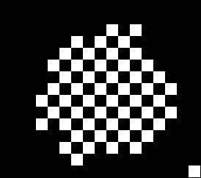 | 
(a) original image | (b) traced by ISBF | (c) traced by the proposed algorithm
Figure 21. Example of untraced contour pixels caused by missing starting pixel
CCITT Image #9 from (1093, 1766) to (1108, 1780)

Figure 22. Result of the proposed algorithm by using bidirectional scanning.

Table X III.
Increases of pixels traced by bi-directional scan from the one-directional scan
 | Total | Proposed |  | ISBF |  | MSBF |  | SBF |  | MNT |  | RSA
 | Number | Number | % | Number | % | Number | % | Number | % | Number | % | Number | %
#1 | 81,189 | 1 | 0.001 | 1 | 0.001 | 1 | 0.001 | 1 | 0.001 | 0 | 0.000 | 0 | 0.000
#2 | 50,825 | 0 | 0.000 | 0 | 0.000 | 0 | 0.000 | 0 | 0.000 | 0 | 0.000 | 0 | 0.000
#3 | 152,489 | 2 | 0.001 | 2 | 0.001 | 3 | 0.002 | 3 | 0.002 | 1 | 0.001 | 1 | 0.001
#4 | 312,812 | 0 | 0.000 | 0 | 0.000 | 0 | 0.000 | 0 | 0.000 | 0 | 0.000 | 0 | 0.000
#5 | 157,377 | 3 | 0.002 | 3 | 0.002 | 0 | 0.000 | 0 | 0.000 | 0 | 0.000 | 0 | 0.000
#6 | 98,579 | 7 | 0.007 | 7 | 0.007 | 8 | 0.008 | 8 | 0.008 | 1 | 0.001 | 1 | 0.001
#7 | 283,717 | 120 | 0.042 | 120 | 0.042 | 67 | 0.024 | 67 | 0.024 | 92 | 0.032 | 92 | 0.032
#8 | 97,031 | 12 | 0.012 | 12 | 0.012 | 15 | 0.015 | 15 | 0.015 | 1 | 0.001 | 1 | 0.001
#9 | 453,721 | 7,075 | 1.559 | 7,076 | 1.560 | 433 | 0.095 | 444 | 0.098 | 3,414 | 0.752 | 3,414 | 0.752
Total | 1,687,740 | 7,220 | 0.428 | 7,221 | 0.428 | 527 | 0.031 | 538 | 0.032 | 3,509 | 0.208 | 3,509 | 0.208

Table X IV.
Computational time traced bi-directionally
* ratio = processing time by bi-directional scanning / processing time of table 8.
 | Proposed |  | ISBF |  | MSBF |  | SBF |  | MNT |  | RSA
Image | Processing  time | ratio | Processing  time | ratio | Processing  time | ratio | Processing  time | ratio | Processing  time | ratio | Processing  time | ratio
#1 | 0.064 | 2.1 | 0.067 | 2.2 | 0.074 | 2.2 | 0.064 | 2.0 | 0.067 | 2.1 | 0.069 | 1.8
#2 | 0.061 | 2.8 | 0.063 | 2.2 | 0.061 | 2.1 | 0.056 | 2.4 | 0.061 | 2.6 | 0.067 | 2.4
#3 | 0.072 | 1.9 | 0.083 | 2.1 | 0.084 | 1.8 | 0.077 | 2.0 | 0.077 | 1.9 | 0.083 | 1.8
#4 | 0.11 | 1.6 | 0.116 | 1.5 | 0.131 | 1.4 | 0.109 | 1.6 | 0.111 | 1.6 | 0.135 | 1.5
#5 | 0.078 | 1.8 | 0.084 | 1.9 | 0.089 | 1.8 | 0.078 | 1.8 | 0.078 | 1.9 | 0.089 | 1.8
#6 | 0.065 | 2.2 | 0.073 | 2.1 | 0.075 | 2.0 | 0.064 | 1.9 | 0.07 | 2.2 | 0.072 | 2.1
#7 | 0.108 | 1.7 | 0.111 | 1.5 | 0.134 | 1.4 | 0.11 | 1.6 | 0.113 | 1.7 | 0.125 | 1.4
#8 | 0.069 | 2.2 | 0.07 | 2.0 | 0.074 | 1.9 | 0.067 | 2.2 | 0.067 | 2.2 | 0.075 | 2.3
#9 | 0.128 | 1.5 | 0.139 | 1.5 | 0.172 | 1.3 | 0.127 | 1.4 | 0.13 | 1.5 | 0.147 | 1.3
Total | 0.755 | 1.8 | 0.806 | 1.8 | 0.894 | 1.6 | 0.752 | 1.8 | 0.774 | 1.8 | 0.862 | 1.7
In the above tables, bidirectional scanning slightly increases [Note: Please check the change.] the number of traced contour pixels, but their processing time increases dramatically. Moreover, the proposed algorithm shows acceptable performance in terms of accuracy (99.5%), although only unidirectional scanning is performed. Hence, unidirectional scanning based on the proposed algorithm is sufficient for application to contour tracing under the condition that a relatively small number of objects are present and real-time tracing such as AR, MR, and recognition-image-based code is performed on small-scale images such as those in a mobile computing environment.

Conclusion
In this paper, we proposed a contour tracing algorithm to trace contours in low-performance devices such as mobile phones, PDAs, and embedded devices that have a processor with limited computational capability and a small memory capacity. The proposed algorithm traces contour pixels based on the pixel following method, and it can also convert the contour information to compressed data and accurately restore it to the original contour by using the vertex following method. The proposed algorithm repeatedly executes the two tracing stages. first, the tracer moves to the next pixel based on its left and left-rear pixels. Next, it moves based on the front and front-left pixels. With these pixel pairs, the contour pixel can be classified into four types, namely, inner corner, outer corner, inner-outer corner, and straight line, and this classification is used to reduce the computational time for tracing the next contour pixel without duplicated detection of the background pixel. Moreover, based on the classified cases, we can determine the representative points and the inner-outer corner points that are based on the coordinates of the vertices, and we can store the contour data as points in order to reduce the data size. In addition, we proposed a restoration algorithm to retrieve all the contour pixels from the representative points and the inner-outer corner points. It performs accurate restoration and it can also restore the inner-outer corners that were not considered in conventional algorithms such as the RD code method and the PXY method. Another characteristic of the proposed algorithm is that it can trace the desired type of connectivity since it is able to distinguish between the connection types of the contour pixels. For example, the proposed algorithm may trace without inner corners, which is similar to the performance of MNT and RSA.
We experimented with regard to three aspects—accuracy, speed, and saving data. In the results of the experiments, the proposed algorithm had the best performance with regard to the accuracy of contour tracing, i.e., it traced the largest number of contour pixels among the algorithms. Moreover, it showed the least average processing time per contour pixel and good performance with respect to the processing time of each image and the LSE. For this reason, it has reasonable performance and based on accuracy and processing time, it is regarded as the best among the algorithms. The proposed algorithm showed good performance with regard to not only the accuracy and speed but also the memory consumption. It stored only the representative points and inner-outer corner points; therefore, it reduced the memory consumption. Besides, the proposed restoration algorithm successfully [Note: Please check the change.] retrieved all the contour pixels from the compressed data. Therefore, the proposed algorithm shows improved accuracy and fast processing of contour tracing, low memory consumption for saving the contour, and good restoration ability.

 

